# WI-FI ENABLED SECURED USB FLASH DRIVE

## INTRODUCTION

This project aims at utilizing this advancement in technology that we have achieved so far to develop a secured wireless system that can perform seamless data transfer to the client over different operating systems. The system tries to increase the mobility and freedom and provide more options to the user towards the access of information.

## OBJECTIVES

### Main objective

To enhance flexibility and security in wireless flash storage devices.

### Specific Objectives

1. To enable reliable wireless data transfer: by enabling data transfer and access with both physical and wireless connections. In this term portability and convenience are considered.
2. To implement secure ways of data transfer: To implement robust security measures to ensure data is protected during transfer.
3. To implement multipoint user-friendly interfaces: To develop an intuitive and user-friendly interface that can cope with at least more than 3 operating systems with windows and Linux included.

## FUNCTIONAL HARDWARE REQUIREMENT

This system is composed of the following

1. Usb interface connector
2. Wi-Fi radio
3. ESP32S3 Controller
4. SD_MMC Nand based memory
5. Battery
6. Charge controller

## FUNCTIONAL BLOCK DIAGRAM

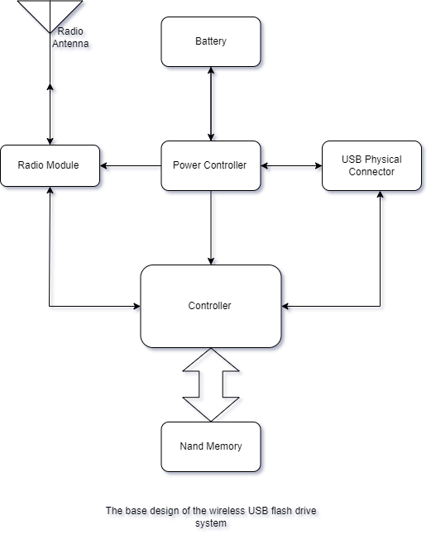

## SYSTEM FLOWCHART

